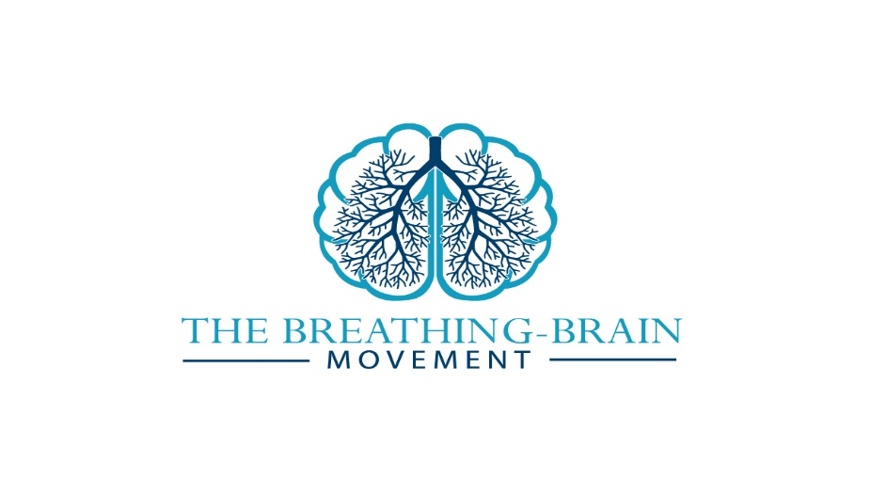

**2019 Autumn Neuro-Rehab Retreat**

**______________________________________________________**

**Day 1:**

9-10 Arrival, registration

10-10:15 Welcome to the retreat and to mind-body practices with neurological patients

Dr Priyanka Pradhan, Consultant Clinical Neuropsychologist & Yoga Instructor, *Neurolistics*; Co-Founder of *The Breathing Brain Movement*

Dr Giles Yeates, Consultant Clinical Neuropsychologist & Taiji/Kung Fu Instructor, *NeuroFlow*; Co-Founder of *The Breathing Brain Movement*

10:15-12:15 **Ayurveda: A 360 Approach to Wellbeing**

Dr Priyanka Pradhan

Incl. Mid-Morning Tea, Coffee and Homemade Cookies

12:30-13:30 Lunch

Two Course Freshly Prepared Lunch served in a 13thCentury Dining room

13:30-15:30 **Traditional Chinese Medicine & Neuro-rehabilitation** (*including TMW movement taster)*

Dr Gavin Farrell, CERU

15:30-6 ***Free Massage & Reflexology sessions*** (5 slots available), Nicola Cale

4- 5 ***Five Animals Qi Gong & Qi Discovery Session***

5-6 ***Wudang Kung Fu***

Dr Giles Yeates

6:30pm Dinner

Two Course freshly prepared Dinner in a 13thCentury Dining Room

Late Evening Optional ***Yoga Nidra Session***, Dr Priyanka Pradhan

**Day 2:**

7-8am Optional ***Led Yoga Session***

Dr Priyanka Pradhan

8-9am Breakfast

Continental breakfast with a wide selection of meats, cheeses**, cereals & yogurts**

9:30- 10:30 **Eastern Approaches to Fatigue Management** *(including Baduanjin Qi Gong Practice)*

Dr Giles Yeates

10:30 -12:30 **Yoga for Trauma after mTBI**

Susi Wrenshaw, Yoga Therapist

Incl Mid-Morning Tea, Coffee and Homemade Cookies

12:30-1:30 Lunch

Two Course Freshly Prepared Lunch served in a 13thCentury Dining room

1:30-3 **Yoga & Recovery from Mild TBI: A personal perspective**

Mariella De Martini, Ashtanga Yoga Instructor

Incl. Afternoon tea, coffee and Homemade Cake

3pm Finish

*All delegates will receive a handout pack plus a pdf bundle of relevant articles. Hard copies of the handouts can be printed out upon advanced request*

