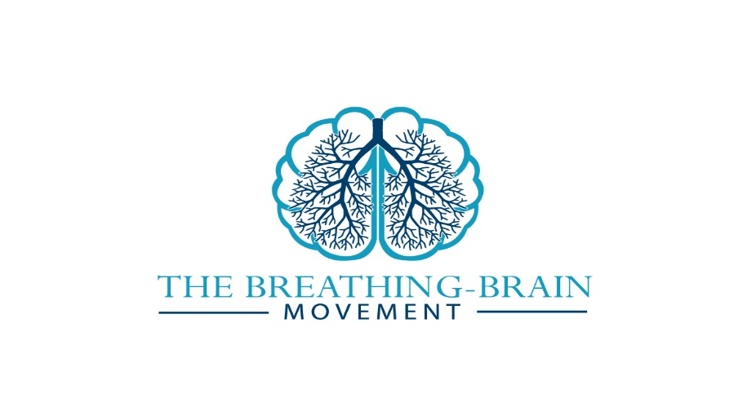
2018 Autumn Neuro-Rehab Retreat
______________________________________________________
Day 1 - Thursday 11th October:
9-10 Arrival, registration: report to main reception, tea/coffee
10-10:15 Welcome to the retreat and to mind-body practices with neurological patients
Dr Priyanka Pradhan, Consultant Clinical Neuropsychologist & Yoga Instructor, Neurolistics; Co-Founder of The Breathing Brain Movement
Dr Giles Yeates, Consultant Clinical Neuropsychologist & Taiji/Kung Fu Instructor, NeuroFlow; Co-Founder of The Breathing Brain Movement
10:15-12:15 Mindfulness for Neurological Patients
Dr Niels Detert, Consultant Clinical Neuropsychologist, John Radcliffe Hospital, Oxford.
Incl. Mid-Morning Tea, Coffee and Homemade Cookies at 11:15
12:30-13:30 Lunch
Two Course Freshly Prepared Lunch served in a 13th Century Dining room
13:30-15:30 Acceptance & Commitment Therapy and Yoga for Neurological Conditions
Dr Priyanka Pradhan
Incl. Afternoon tea, coffee and Homemade Cake at 14:30
4-6 Free Massage & Reflexology sessions, Nicola Cale
4- 5 Optional Wudang Tai Ji session 5-5:30 Optional Wudang Kung Fu session
Dr Giles Yeates
6:30pm Dinner
Two Course freshly prepared Dinner in a 13th Century Dining Room
8-9pm Free Massage & Reflexology sessions, Nicola Cale
Late Evening Optional Yoga Nidra Session, Dr Priyanka Pradhan

Day 2 – Friday 12th October:
7-8am Optional Led Yoga Session
Dr Priyanka Pradhan
7-9am Breakfast
Continental breakfast with a wide selection of meats, cheeses, cereals & yogurts
10-12 Yoga & Pain in Neurological Conditions
Anni Jakenfelds, Yoga Teacher & Health & Wellness Practitioner, The Integrative Healing Process
Incl Mid-Morning Tea, Coffee and Homemade Cookies at 11:00
12-1 Lunch
Two Course Freshly Prepared Lunch served in a 13th Century Dining room
1-3 Flow State Experience and Tai Chi for Neurological Conditions
Dr Giles Yeates
Incl. Afternoon tea, coffee and Homemade Cake at 14:00
3pm Finish

All delegates will receive a handout pack plus a pdf bundle of relevant articles. Hard copies of the handouts can be printed out upon advanced request

